JSPM'S
RAJARSHI SHAHU COLLEGE OF ENGINEERING, PUNE
Department of Computer Science and Business Systems
Academic Year: 2026–27
S.Y. B.Tech – Semester III
MINI PROJECT REPORT
ON
SMART CANTEEN PRE-ORDER & TOKEN SYSTEM
Submitted by
Sr. No. | Name | PRN No. / Roll No.
1 | Saurav Bhonde | RBT25ET027 (67)
2 | Parth Mohurle | RBT25ET072 (68)
3 | Ankita Kamble | RBTL26CB067 (69)
Department of Computer Science and Business Systems

1. Title of the Project
Smart Canteen Pre-Order & Token System

2. Problem Statement
In colleges, students often face long queues at the canteen during lunch breaks and short intervals. The traditional ordering process requires students to wait, check available food items, place orders manually, and collect food after preparation. This can lead to delays, overcrowding, and difficulties in managing food stock and customer orders.
The Smart Canteen Pre-Order & Token System is a menu-driven Java application designed to simplify canteen ordering. Students can view the menu, select food items, specify quantities, place orders, receive unique tokens, calculate bills, and track order status. Canteen staff can add or remove menu items, view orders, and update their status.

3. Objective
- To develop a menu-driven canteen management application using Core Java.
- To display available food items, prices, categories, and stock quantities.
- To allow students to add items to a cart and place orders.
- To generate a unique token for every order during program execution.
- To calculate bills automatically using item prices and quantities.
- To track orders through Placed, Preparing, Ready, and Collected statuses.
- To provide staff facilities for adding and removing menu items and viewing orders.
- To validate item quantities and stock availability before confirming orders.
- To demonstrate inheritance, polymorphism, interfaces, encapsulation, collections, and exception handling.

4. Methodology

4.1 Requirement Analysis
The main requirements are menu display, cart management, order placement, bill calculation, token generation, order tracking, and staff management of menu items and orders.

4.2 System Design
- Menu Management: stores item IDs, names, prices, categories, and stock.
- Student Module: supports menu viewing, cart operations, order placement, and token tracking.
- Staff Module: supports adding and removing menu items, viewing orders, and advancing order status.
- Order Management: maintains tokens, student details, ordered items, quantities, and statuses.
- Billing Module: calculates the total amount according to each item's pricing rule.
- Exception Handling: reports invalid IDs, invalid tokens, empty carts, invalid quantities, and insufficient stock.

4.3 Implementation Approach
The application uses Core Java and object-oriented design. Menu items and orders are stored in collections in memory. A console-based interface provides numbered options. Before confirming an order, the program validates the selected items and quantities against available stock. If validation succeeds, stock is updated, an order token is generated, and the order is stored.

4.4 Testing Approach
Suggested test cases include displaying the menu, placing a valid order, calculating a bill, tracking a valid token, entering an invalid token, requesting more items than available stock, using invalid quantities, and entering an incorrect staff password. These are proposed test cases; results should be recorded after running the application.

5. Dataset, Tools & Technologies Used

5.1 Dataset
The application initializes the following sample menu items directly in the Java code:
Item Name | Category | Base Price (Rs.) | Initial Stock
Tea | Beverage | 10 | 50
Cold Coffee | Beverage | 40 | 20
Samosa | Snack | 15 | 40
Sandwich | Snack | 35 | 25
Veg Thali | Meal | 80 | 30

5.2 Tools and Technologies
- Programming Language: Java (Core Java).
- Development Environment: Any Java-compatible IDE, such as IntelliJ IDEA, Eclipse, or Visual Studio Code.
- Java Concepts: classes, objects, inheritance, polymorphism, encapsulation, abstract classes, interfaces, enums, and exception handling.
- Collections: LinkedHashMap, TreeMap, Map, and Collection.
- Input Handling: Scanner.
- Application Type: Console-based application.
The current implementation stores data in memory. It does not use JDBC, a database, or a graphical user interface.

6. Implementation

6.1 CanteenException
CanteenException is a custom checked exception used for application-specific errors, including invalid item IDs, invalid order tokens, an empty cart, insufficient stock, invalid quantities, and attempts to advance an already collected order.
import java.util.*;

// Exception handling: custom checked exception
class CanteenException extends Exception {
CanteenException(String m) { super(m); }
}

6.2 MenuItem Class
MenuItem is an abstract class representing a general menu item. It stores the item ID, name, price, and stock. Private fields and accessor methods support encapsulation. The abstract methods finalPrice() and type() are implemented by subclasses.
// Encapsulation + Inheritance + Polymorphism: menu items
abstract class MenuItem {
private static int counter = 100;
private final int id = ++counter;
private final String name;
private double price;
private int stock;

MenuItem(String name, double price, int stock) {
this.name = name; setPrice(price); setStock(stock);
}
int getId() { return id; }
String getName() { return name; }
double getPrice() { return price; }
int getStock() { return stock; }
void setPrice(double p) { if (p <= 0) throw new IllegalArgumentException("Price must be > 0"); price = p; }
void setStock(int s) { if (s < 0) throw new IllegalArgumentException("Stock cannot be negative"); stock = s; }
abstract double finalPrice(); // polymorphic pricing
abstract String type();
public String toString() {
return String.format("%-5d %-16s %-9s Rs.%-7.2f Stock:%d", id, name, type(), finalPrice(), stock);
}
}

6.3 Menu Item Subclasses
Beverage returns the base price. Snack adds a packing charge of Rs. 5. Meal adds 5% to the base price. These subclasses demonstrate inheritance and polymorphism. The code implements the meal surcharge as a pricing rule; it should only be described as GST if that is the intended project requirement.
class Beverage extends MenuItem {
Beverage(String n, double p, int s) { super(n, p, s); }
double finalPrice() { return getPrice(); }
String type() { return "Beverage"; }
}
class Snack extends MenuItem {
Snack(String n, double p, int s) { super(n, p, s); }
double finalPrice() { return getPrice() + 5; } // packing charge
String type() { return "Snack"; }
}
class Meal extends MenuItem {
Meal(String n, double p, int s) { super(n, p, s); }
double finalPrice() { return getPrice() * 1.05; } // 5% GST
String type() { return "Meal"; }
}

6.4 User, Student, and Admin Classes
User is an abstract class containing the user's name and an abstract role() method. Student and Admin inherit from User. The Student role is used for ordering and tracking, while Admin represents staff functions.
// Inheritance + Polymorphism: users
abstract class User {
private final String name;
User(String name) { this.name = name; }
String getName() { return name; }
abstract String role();
}
class Student extends User {
Student(String n) { super(n); }
String role() { return "Student"; }
}
class Admin extends User {
Admin(String n) { super(n); }
String role() { return "Staff"; }
}

6.5 Billable and Manageable Interfaces
Billable defines the total() method for calculating an order amount. Manageable defines addItem() and removeItem() operations. The Canteen class implements Manageable.
// Interfaces
interface Billable { double total(); }
interface Manageable {
void addItem(MenuItem i);
void removeItem(int id) throws CanteenException;
}

6.6 Order Class
Order stores the token, student, selected menu items, quantities, and status. It calculates the bill and advances the order through PLACED, PREPARING, READY, and COLLECTED. The program prevents the status from advancing beyond COLLECTED.
enum Status { PLACED, PREPARING, READY, COLLECTED }

// Order implements Billable
class Order implements Billable {
private static int counter = 0;
private final int token = ++counter;
private final Student student;
private final Map<MenuItem, Integer> items = new LinkedHashMap<>();
private Status status = Status.PLACED;

Order(Student s) { student = s; }
int getToken() { return token; }
Student getStudent() { return student; }
Status getStatus() { return status; }
void add(MenuItem m, int qty) { items.put(m, qty); }

public double total() {
double t = 0;
for (Map.Entry<MenuItem, Integer> e : items.entrySet()) t += e.getKey().finalPrice() * e.getValue();
return t;
}
void advance() throws CanteenException { // PLACED -> PREPARING -> READY -> COLLECTED
if (status == Status.COLLECTED) throw new CanteenException("Order already collected");
status = Status.values()[status.ordinal() + 1];
}
void bill() {
System.out.println("\n===== BILL | Token #" + token + " | " + student.getName() + " =====");
for (Map.Entry<MenuItem, Integer> e : items.entrySet())
System.out.printf("%-16s %d x %.2f = %.2f%n", e.getKey().getName(), e.getValue(),
e.getKey().finalPrice(), e.getKey().finalPrice() * e.getValue());
System.out.printf("TOTAL: Rs. %.2f | Status: %s%n", total(), status);
}
}

6.7 Canteen Class
Canteen manages menu items and orders. A LinkedHashMap stores menu items in insertion order, while a TreeMap stores orders by token. The placeOrder() method validates all requested items and quantities before changing stock and saving the order.
// Collections: Map for menu and orders
class Canteen implements Manageable {
private final Map<Integer, MenuItem> menu = new LinkedHashMap<>();
private final Map<Integer, Order> orders = new TreeMap<>();

public void addItem(MenuItem i) { menu.put(i.getId(), i); }
public void removeItem(int id) throws CanteenException { find(id); menu.remove(id); }

MenuItem find(int id) throws CanteenException {
MenuItem m = menu.get(id);
if (m == null) throw new CanteenException("No item with ID " + id);
return m;
}
Order order(int token) throws CanteenException {
Order o = orders.get(token);
if (o == null) throw new CanteenException("No order with token #" + token);
return o;
}
void showMenu() { menu.values().forEach(System.out::println); }
Collection<Order> allOrders() { return orders.values(); }

Order placeOrder(Student s, Map<Integer, Integer> cart) throws CanteenException {
if (cart.isEmpty()) throw new CanteenException("Cart is empty");
for (Map.Entry<Integer, Integer> e : cart.entrySet()) { // validate first
MenuItem m = find(e.getKey());
if (e.getValue() <= 0) throw new CanteenException("Invalid quantity for " + m.getName());
if (e.getValue() > m.getStock())
throw new CanteenException("Only " + m.getStock() + " left for " + m.getName());
}
Order o = new Order(s); // then commit
for (Map.Entry<Integer, Integer> e : cart.entrySet()) {
MenuItem m = menu.get(e.getKey());
m.setStock(m.getStock() - e.getValue());
o.add(m, e.getValue());
}
orders.put(o.getToken(), o);
return o;
}
}

6.8 SmartCanteen Main Class
SmartCanteen contains the main() method and console menus. Students can view the menu, add items to a cart, place orders, view bills, and track tokens. Staff can add or remove menu items, view all orders, and advance order status. The staff login uses a simple hard-coded password, admin123, for demonstration.
public class SmartCanteen {
static final Canteen canteen = new Canteen();
static final Scanner sc = new Scanner(System.in);

static int readInt(String p) {
while (true) {
System.out.print(p);
try { return Integer.parseInt(sc.nextLine().trim()); }
catch (NumberFormatException e) { System.out.println("Enter a valid number."); }
}
}

public static void main(String[] args) {
canteen.addItem(new Beverage("Tea", 10, 50));
canteen.addItem(new Beverage("Cold Coffee", 40, 20));
canteen.addItem(new Snack("Samosa", 15, 40));
canteen.addItem(new Snack("Sandwich", 35, 25));
canteen.addItem(new Meal("Veg Thali", 80, 30));
while (true) {
int ch = readInt("\n1.Student 2.Staff 0.Exit: ");
if (ch == 0) break;
if (ch == 1) student(); else if (ch == 2) admin(); else System.out.println("Invalid choice.");
}
}

static void student() {
System.out.print("Your name: ");
Student s = new Student(sc.nextLine().trim());
Map<Integer, Integer> cart = new LinkedHashMap<>();
while (true) {
int ch = readInt("\n[" + s.role() + "] 1.Menu 2.Add to cart 3.Place order 4.Track 0.Back: ");
try {
switch (ch) {
case 1: canteen.showMenu(); break;
case 2: {
MenuItem m = canteen.find(readInt("Item ID: "));
cart.merge(m.getId(), readInt("Qty: "), Integer::sum);
System.out.println("Added " + m.getName()); break;
}
case 3: { Order o = canteen.placeOrder(s, cart); cart.clear(); o.bill(); break; }
case 4: { Order o = canteen.order(readInt("Token: ")); System.out.println("Token #" + o.getToken() + " -> " + o.getStatus()); break; }
case 0: return;
default: System.out.println("Invalid choice.");
}
} catch (CanteenException e) { System.out.println("Error: " + e.getMessage()); }
}
}

static void admin() {
System.out.print("Password: ");
if (!sc.nextLine().equals("admin123")) { System.out.println("Wrong password."); return; }
User a = new Admin("Staff");
while (true) {
int ch = readInt("\n[" + a.role() + "] 1.Menu 2.Add item 3.Remove item 4.Orders 5.Advance status 0.Back: ");
try {
switch (ch) {
case 1: canteen.showMenu(); break;
case 2: {
int t = readInt("Type (1 Beverage, 2 Snack, 3 Meal): ");
System.out.print("Name: "); String n = sc.nextLine().trim();
int p = readInt("Price: "), st = readInt("Stock: ");
if (t == 1) canteen.addItem(new Beverage(n, p, st));
else if (t == 2) canteen.addItem(new Snack(n, p, st));
else if (t == 3) canteen.addItem(new Meal(n, p, st));
else System.out.println("Unknown type.");
break;
}
case 3: canteen.removeItem(readInt("Item ID: ")); System.out.println("Removed."); break;
case 4:
for (Order o : canteen.allOrders())
System.out.printf("Token #%d | %s | Rs.%.2f | %s%n", o.getToken(), o.getStudent().getName(), o.total(), o.getStatus());
break;
case 5: { Order o = canteen.order(readInt("Token: ")); o.advance(); System.out.println("Now: " + o.getStatus()); break; }
case 0: return;
default: System.out.println("Invalid choice.");
}
} catch (CanteenException | IllegalArgumentException e) { System.out.println("Error: " + e.getMessage()); }
}
}
}

6.9 Billing Logic
Total Bill = Sum of (Final Item Price × Quantity)
Example: two teas and one samosa produce the following bill:
Item | Quantity | Unit Price (Rs.) | Subtotal (Rs.)
Tea | 2 | 10.00 | 20.00
Samosa | 1 | 20.00 | 20.00
TOTAL |  |  | 40.00
The samosa's final price is Rs. 20 because the code adds a Rs. 5 packing charge to its Rs. 15 base price.

7. Results
The program is designed to provide a basic console-based solution for canteen ordering and administration. Its implemented features include:
- Displaying menu items with IDs, categories, prices, and stock.
- Adding selected items and quantities to a student cart.
- Validating stock and quantities before order placement.
- Generating an order token during program execution.
- Calculating and displaying bills.
- Tracking order progress using four predefined statuses.
- Adding and removing menu items through the staff module.
- Displaying recorded orders with student names, token numbers, totals, and statuses.
- Handling several invalid operations through exceptions.
The application stores data in memory, so menu changes, stock updates, and orders are lost when the program closes. The results listed above describe the code's designed functionality; actual test outcomes should be filled in after running the program.

7.1 Student Module Output
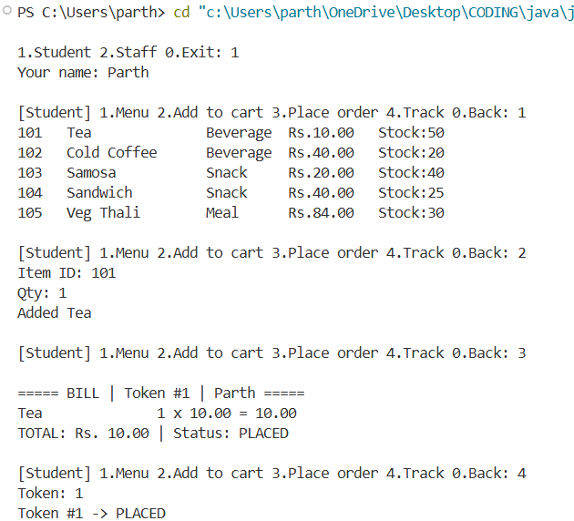
Figure 1: Student module – viewing menu, adding to cart, placing order and tracking token

7.2 Staff Module Output
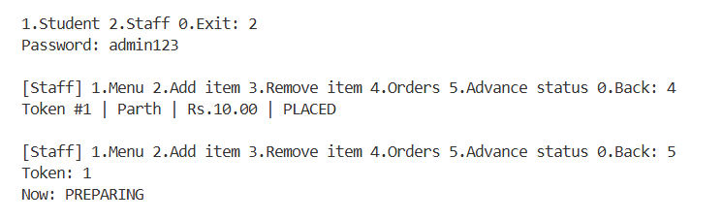
Figure 2: Staff module – viewing orders and advancing order status

8. Conclusion
The Smart Canteen Pre-Order & Token System demonstrates how Core Java and object-oriented programming can be applied to a college canteen scenario. It provides basic facilities for viewing food items, placing orders, calculating bills, generating tokens, tracking order progress, and managing menu items.
The project incorporates inheritance, polymorphism, encapsulation, abstract classes, interfaces, Java collections, and exception handling. Future improvements could include database integration using JDBC with PostgreSQL or MySQL, a graphical or web-based interface, secure staff authentication, online payments, and sales and inventory reports.
Overall, this mini project provides practical experience in Java programming, object-oriented design, collection management, and exception handling while providing a foundation for a more advanced canteen management system.

